Newsletter
Summer Term 2nd Half (June – July 2019)
We hope you had a fun and restful half-term holiday.
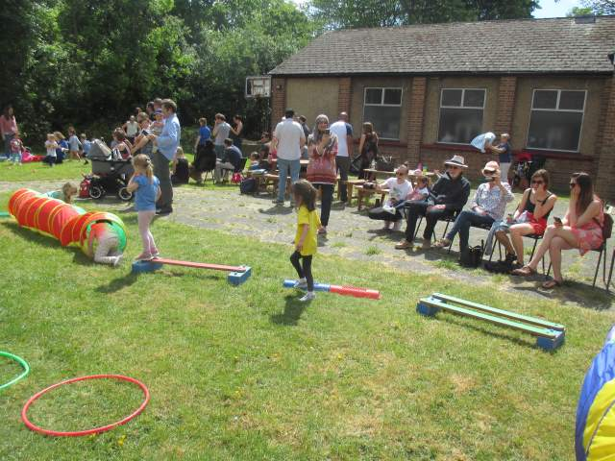
Sports Day: Thank you all for coming along to support the children’s sports day at the end of last half term. I hope you enjoyed the event as much as we did!

Spring Fete: We had a lovely afternoon of fun and ate quite a lot of cake. All your efforts raised about £460. Thank you so much to the Committee for organising and running the event; and to everyone who supported the afternoon.
Healthy Eating: we are planning some activities over the next few weeks around healthy eating and activities. We know our Pre-School families represent a wide and diverse community. There may be familiar foods that you eat at home that we might not necessarily offer to the children at snack time. Would you let us know if there are any favourite, community foods that your child likes to eat or might be encouraged to try? If you’re willing to donate small samples, that would be even better! Just a reminder, though, about no nuts in the foods we offer at snack time.
Office Role-Play: do you have any old computer keyboards, phones (analogue or old flip mobiles etc) or other office-y type equipment gathering dust at home? We are looking to extend our role-play activities and would like to set up a play office every now and then. If you have any old (safe) equipment, we would be pleased to take donations.
Water play day: we are planning a wild, wet and water focussed activity week, 17th-21st June. In particular, we would like to offer a water play day, probably on Wednesday 19th June. (We are a bit weather dependent and plans may change.) Please would you make sure your child has a change of clothes available during this week, if possible.
Parent consultations: we are holding our end-of-year parent consultations on Friday 28th June. A separate letter has been issued. The sign-up sheet is on the hall door. We will not be running a usual session on this date.
End of Year celebrations: we have a number of events planned. These events are funded from the fundraising mentioned above, and that which has taken place over the last year.
Monday 15th July: ZooLab are visiting to provide an animal encounter session for the children.
Friday 19th July: Summer outing. Carrying on with the ‘natural world’ theme, we’re planning our annual walk around the Highams Park lake on Friday 19th July. We will meet at the Park, and then rendezvous again with you all at Humphry’s cafe.
Monday 22nd July: Last day of term and graduation. We will be hosting a graduation/celebration on the last day. You are invited to join us, 10.45 for 11.00am. Pre-School will close at 11.30am.
More details on these events will be available nearer the time. All children are invited to attend, whether or not they usually come to Pre-School on the days given.
Weather
Hopefully the weather will be consistently nice over the next half term. If so, please make sure your child has appropriate clothing, particularly if it is hot or sunny. Please ensure that sun screen is applied before your child comes into Pre-School. We can only apply sun screen to your child if there is a medical need to do so. (If your child does have a medical need, please have a word.)
Please make sure your child’s clothing (sun hats etc) is clearly named.
Stay and Play
...will be Tuesday – Thursday 16th-18th July. A sign-up form will be on the door from the week before. On this occasion, preference will be given to parents who have not attended before and/or parents of children who are leaving.
Future Diary Dates
For returners, Pre-School starts on Thursday 5th September, 9.00am.
Please do not hesitate to have a word if you have any questions or comments. Janet

